**Apache Redirect HTTP to HTTPS**

Apache’ makes it easy to require SSL to be used on your site and to gently redirect users who forget to add the https when typing the URL. Using Apache to redirect http to https will make sure that your site (or a part of it) will only be accessed by your customers using SSL.  This is better than using SSLRequireSSL because users often forget to type in the https and will be automatically redirected.

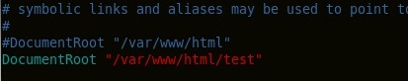

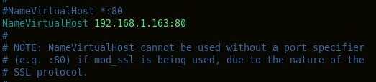

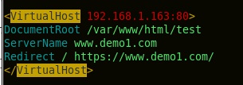

**<VirtualHost 192.168.1.163:80>**

**DocumentRoot /var/www/html/test**

**ServerName www.demo1.com**

**Redirect / https://www.demo1.com/**

**</VirtualHost>**

**# Vim /etc/hosts**

**Add Alias name of the web site in diffrent name**

